**TOOLS**



## Table of Contents

Accessing Google Drive 3

Signing Up for Google account 4

Introduction to Google Docs 5

Adding file to Google Drive 6

Convert uploaded document to Google Docs 8

Share Documents with Others 9

Collaborate With Other Editors 14

Collaborate With Other Commenter 16

## Figure Table of Contents

Figure 1 Accessing Google Drive from Chrome home page. ...................................................... 3

Figure 2 Accessing Google Drive via the URL............................................................................ 3

Figure 3 Google Drive welcome page ........................................................................................ 4

Figure 4 Registration Completed ................................................................................................ 5

Figure 5 Our Google Drive Page ................................................................................................ 6

Figure 6 Uploading existing file onto Google Drive ..................................................................... 7

Figure 7 File uploaded complete ................................................................................................ 7

Figure 8 Upload file appear in file list......................................................................................... 7

Figure 9 Word file uploaded onto Drive...................................................................................... 8

Figure 10 Converting Word document to Google Docs.............................................................. 8

Figure 11 Original Word document alongside its converted counterpart ..................................... 9

Figure 12 Sharing document with other editors.......................................................................... 9

Figure 13 Sharing settings panel ...............................................................................................10

Figure 14 Sharing settings for the document .............................................................................11

Figure 15 Adding a collaborator to document ............................................................................11

Figure 16 Adding a Commenter to a Google Document ............................................................12

Figure 17 Completed sharing setting .........................................................................................13

Figure 18 Settings for what editors can do ................................................................................13

Figure 19 Editor will see that a new document has been shared ...............................................14

Figure 20 Shared file open in Google Docs ...............................................................................14

Figure 21 Message sent by editor appeared at the top of the document ...................................15

Figure 22 Chat panel allows collaborators to discuss content of the document .........................15

Figure 23 Google Docs interface for commenter .......................................................................16

Figure 24 Insert comment button ..............................................................................................16

Figure 25 Comment panel .........................................................................................................17

# 

# Accessing Google Drive

There are few methods in which we can access the Google Drive; the easiest way is by using a Chrome browser. In Chrome, we click on a new browser or a new tab, we will be presented with the following page. Just click on the Google Drive logo and we will be directed to Google drive website.

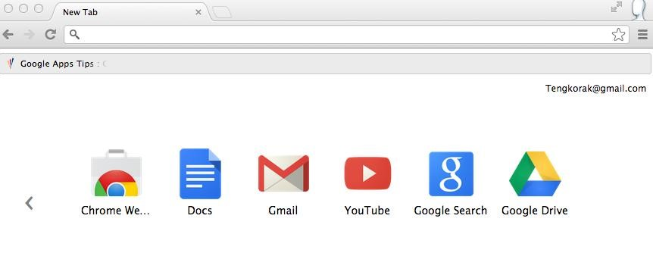

**Figure 1 Accessing Google Drive from Chrome home page.**

If we do not have a Chrome browser then we can access Google Drive by entering the following URL on our browser, http://drive.google.com.

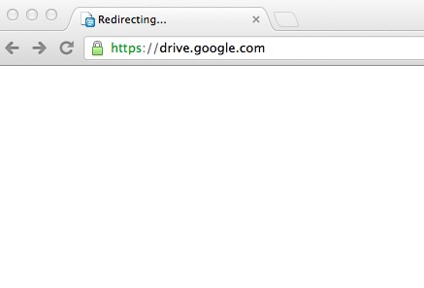

**Figure 2 Accessing Google Drive via the URL**

Or we also just Google for “Google Drive”, which should also bring us to the following page:

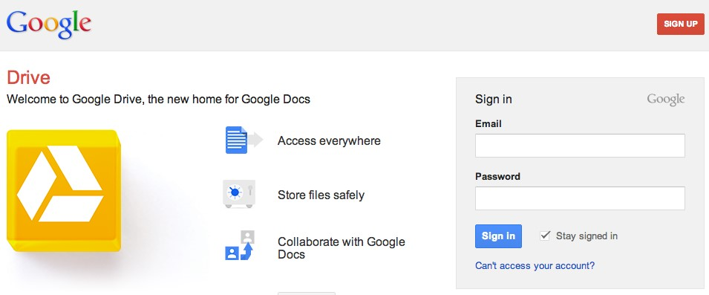

**Figure 3 Google Drive welcome page**

In order to use Google Drive, we are required to have a Google account. If you already own a Google account then just continue with signing in, for those of us who is yet to create an account, we will continue with signing up for Google account.

# Signing Up for Google account

On the Google Drive welcome page, there is a bright red button up on the top right corner with the words “SIGN UP”, click on the button to create your account. We should get the following page.

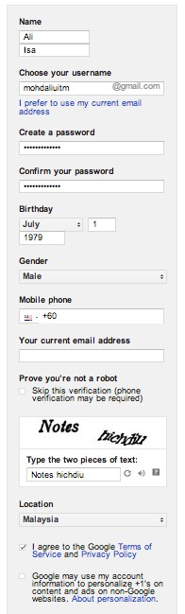Just fill in the required information, note that all the information is required except for the field “*Mobile Phone*” and “*Your current email address*”. Both these fields will only be used for security purposes such as when you would like to prove that you are the owner of the account.

There are cases where an account was hacked. In order to get the account back, Google would ask you to verify that you are the owner by sending messages or an email to the phone number and email address provided.

It is recommended that you fill in both these two fields but it does not have to be filled during registration and you can always fill them up later.

Another important option is the link “I would like to use my current email address”. By default, when you would like to get a Google account, Google will provide us with a Google mail account (Gmail account). This is an email account with the gmail.com domain at the end.

We are recommending new user, who does not have any Gmail account to get your own Gmail account. The reason is simple, later on when we are using Google apps such as Google Drive, periodically Google will sends us some notification about our account. Let’s say there is someone who commented on our shared documents, we will receive email notification about that, or if someone edited our documents, we will receive email notification about that too. So it is better that this email is delivered to other email account so that it does not interfere with our email account at work.

Once we have completed the form, please make sure you tick on the checkbox with the text:

*“I agree to the Google Terms of Service and Privacy Policy”*

or you will not be able to submit. Verify that all information is correct and submit the form. We should get the following page. Click on the “Back to Google Docs” button to get started!

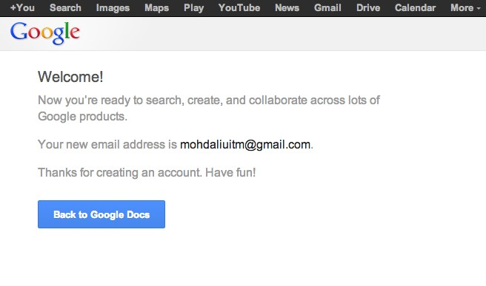

**Figure 4 Registration Completed**

# Introduction to Google Docs

Google Docs is an online version of Microsoft Word, PowerPoint and Excel. In Google Docs they are called Google Document, Spreadsheet and Presentation.

After we complete our registration we will be directed to the following Google Drive page:

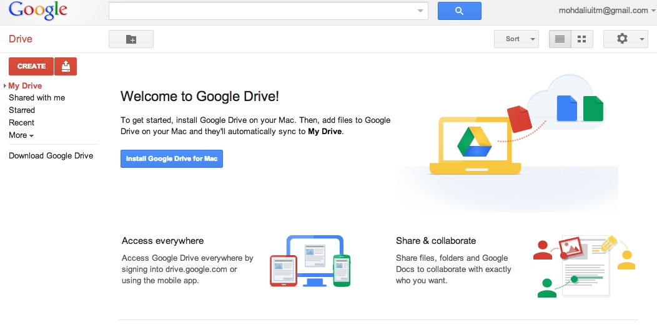

**Figure 5 Our Google Drive Page**

In Figure 4 we can see that Google Drive panel is divided into three parts. On the left is the folder view which shows any files shared with us, starred files and recently modified files. At the top is the menu bar which contains options such as creating new folders, sorting files, viewing options, as well as settings. The center is the area where files in the Drive will be display, but since we do not have any files yet, this is shows information about Google Drive.

# Adding file to Google Drive

There are two methods in which files can be created in the Drive. The first method is by creating an empty file from scratch. This can be done by simply clicking on the “CREATE” button. The second method is by uploading an existing file onto Drive and editing it afterwards.

To add existing file to Google Drive, click on the hard disk with arrow up button beside create button, and choose files.

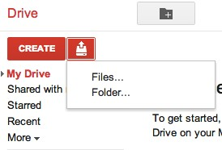

**Figure 6 Uploading existing file onto Google Drive**

We will be presented with an upload file panel. Browse for the file that you would like to upload, click on the file and choose upload. Once completed we should get the panel such as figure below:

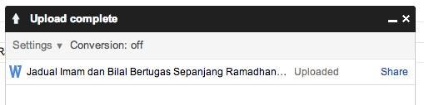

**Figure 7 File uploaded complete**

Click close (x) on the upload panel and we should see the file in our drive main page.

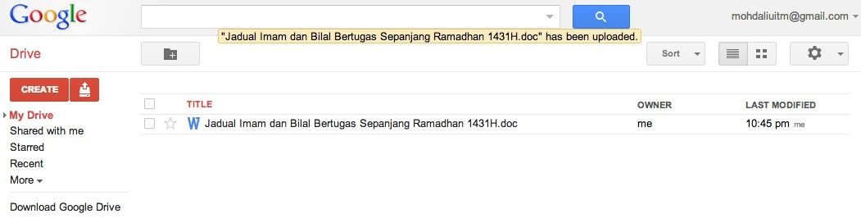 **Figure 8 Upload file appear in file list**

# Convert uploaded document to Google Docs

Notice that when we uploaded the file, the file has the icon W at the side of its file name. This means that the file is still a Word document and not a Google Docs document. Bear in mind that we can only do editing on a Google Docs file and not on a Microsoft Word document. Try and click on the file just uploaded to view the content of the file.

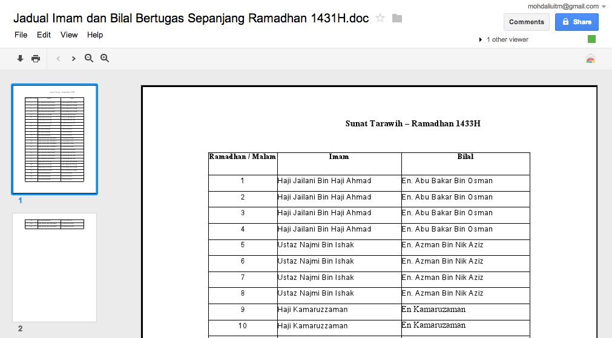

**Figure 9 Word file uploaded onto Drive**

Notice that when a document is in its original form, we are unable to edit the document. To make the document editable, click on File > Open with > Google Docs.

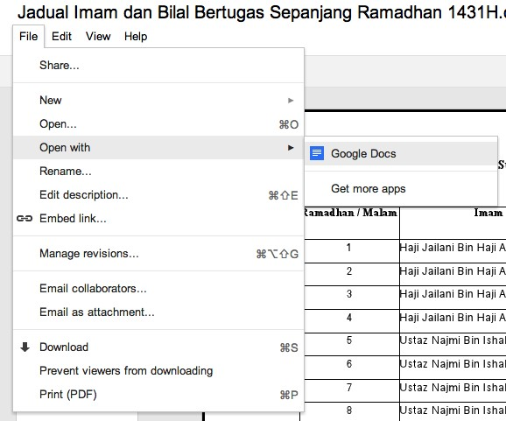

**Figure 10 Converting Word document to Google Docs**

This will save the original file as Google Docs and open up the file in a separate editor. We will now be able to make changes to the file. Let us close the editor and go back to our Google Drive home. Notice that now in our file list there are two files, the uploaded Microsoft Word file, and the converted Google Document file.

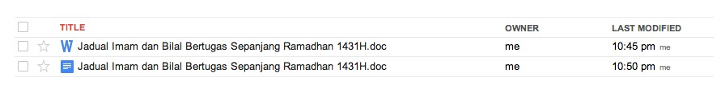

**Figure 11 Original Word document alongside its converted counterpart**

As can be seen in Figure 10, although we converted the uploaded Word document into Google Docs, the original file is not modified and still exist in our drive. Click again on the Google Docs to do some editing on the file.

# Share Documents with Others

One of the most powerful features of Google Docs is that it is a collaborative tool. Google Docs allows us to have multiple people editing the same files at the same time and ensure that all modification can be seen by all editors. This is useful when we have a single document that requires multiple input from different users for example program agenda.

To share a document, follow these steps:

1. Click on the document that we would like to edit.

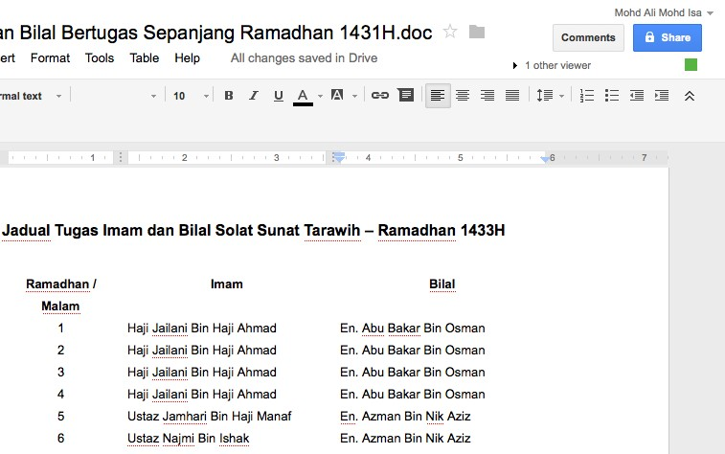

**Figure 12 Sharing document with other editors**

1. Click on the **Share** button (refer to Figure 11)

1. A “Sharing settings” panel will appear.

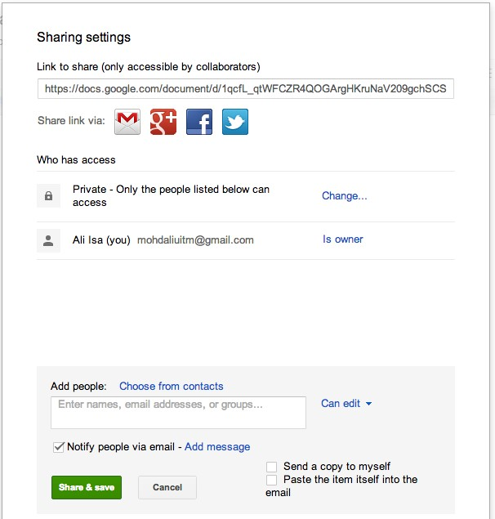

**Figure 13 Sharing settings panel**

“Link to share” is the URL that will be sent to the people that we want to collaborate with on the document. The URL for the document can be made public (i.e., we can put it on a website) because only those who have been granted access can view the document.

Under section “Who has access”, it shows two pieces of information. The first information shows the sharing settings of the document, currently there are three settings options available:

Public on the web: This means that document is searchable on the Internet. Anyone who manages to find it, modify the document.



Anyone with the link: Document will not be searchable, only those who have the link can access the document.



Private: Only people explicitly given access can access the document. Users are required to sign-in to access the document.



Figure 13 shows the sharing settings.

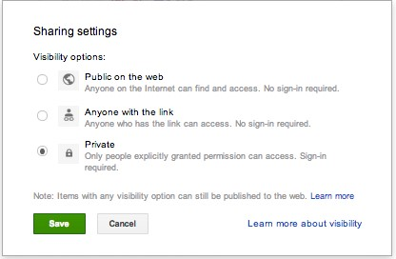

**Figure 14 Sharing settings for the document**

If the document is marked as private then we must explicitly specify who can access the document.

1. Add people as collaborator (editor)

To add collaborators, we need to insert their email address in the Add People field. We can add as many collaborators up to the maximum of 200 peoples.

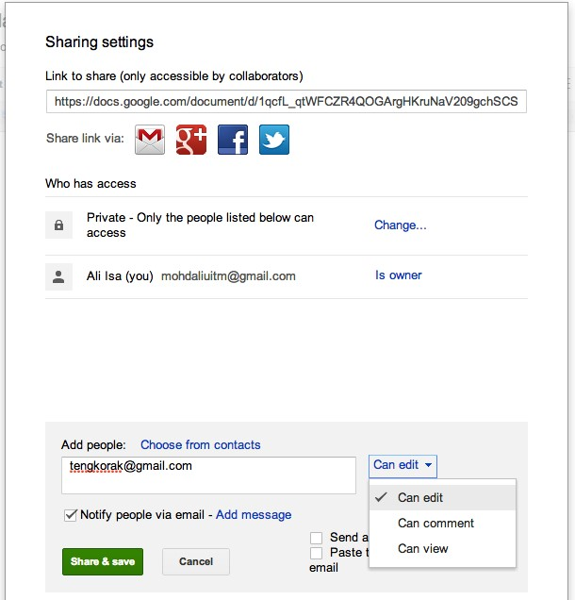

**Figure 15 Adding a collaborator to document**

Enter one of your partner email address and then click Share and Save. If you would like to send your partner an email, please do not forget to tick on the “notify people via email” option, otherwise we will have to manual email our partner the link.

1. Add people as collaborator (commenter)

There are times during collaboration where we would like some people to be able to view the file but does not modify the file. That person is a commenter. They are allowed to view the file and leave comments about the content of the file. To add a commenter, the step is similar to adding and editor, except when entering and email address, we click on the “can edit” link and change it “can comment”.

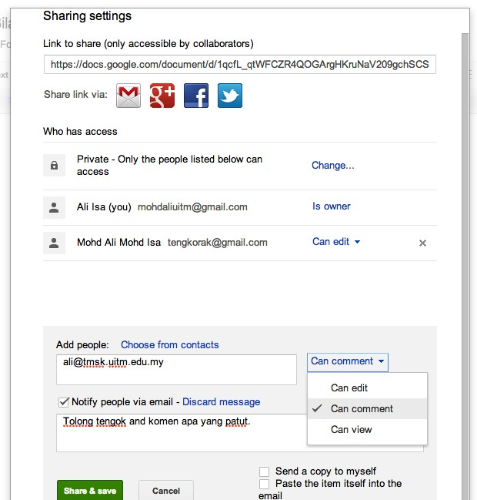

**Figure 16 Adding a Commenter to a Google Document**

Click on Share and save. The collaborator will get an email saying that we would like them to review our file.

This is the power of Google Docs. We have great control over who can access the file and what they can do with the file. A feature that currently is not available elsewhere.

Once we are finish, verify the list of people that we have allowed access to the file.

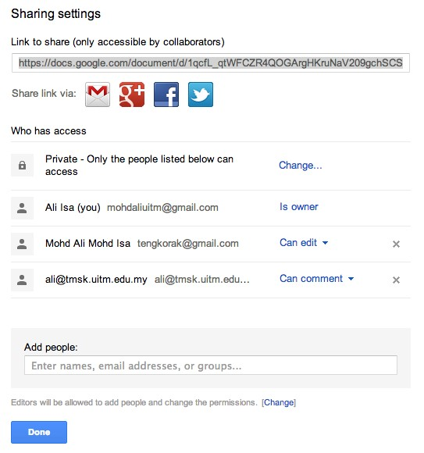

**Figure 17 Completed sharing setting**

Click on Done so that the file can now be accessed by others collaborators.

There is one important option worth mentioning. When we add an editor as a collaborator, an editor can also add others collaborators and modify the permissions of the file. If the owner would like to set so that no other person can add new collaborators, click on the “change” button beside the “Editors will be allowed to add people and change the permissions” options.

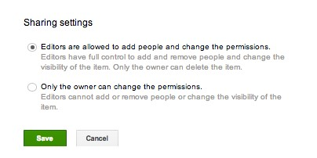

**Figure 18 Settings for what editors can do**

Usually we will choose the option **“only the owner can change the permissions.”**  We have now completed adding collaborators to our Google Docs document.

# Collaborate With Other Editors

In the previous section we have covered how Google Docs can be shared with other people and how they can be assigned as editor or commenter. We will first look at the role of editor first. When an editor logs into their Google Drive account, and clicks on “Shared with me”, they will see that a new document has been shared with them. At this point though, the user will only know that there is a file being shared but do not know what is the access given to them.

1. Login into your Google Drive account and you should see a shared file.

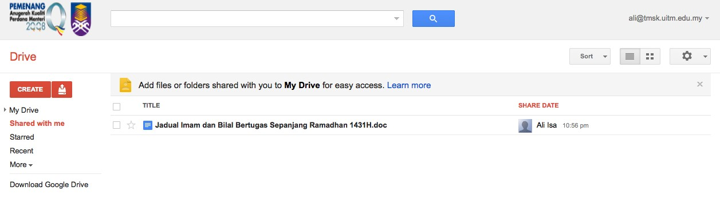

**Figure 19 Editor will see that a new document has been shared**

1. Click on the file name to open the file in Google Docs.



**Figure 20 Shared file open in Google Docs**

Notice that when the file is opened, you get to see all of the buttons required for editing such as **Bold,** *Italics* and underline. This indicates that you are assigned as editor and you are allowed to edit the file.

Since Google Docs is a real-time document collaboration tools, others collaborators may view and edit the file at the same time as you are. If there are other collaborators online, Google Docs will show the number of users currently viewing the file under the Comments button. In Figure 19 we can see that there is one other person viewing the file. This means we can click on the link and have a chat with the other person.

You can click on the link and send the other person a message.

In figure 21, we can that an editor sent a message to the document owner and the owner can read the message.

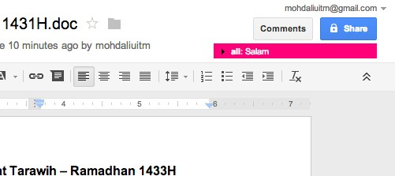

**Figure 21 Message sent by editor appeared at the top of the document**

4. Click on the message to reply.

This will open up a new chat panel that allows both of you and the other collaborator to exchange messages and discuss matters related to the document.

.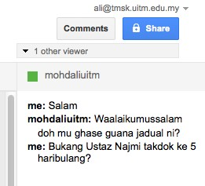

**Figure 22 Chat panel allows collaborators to discuss content of the document**

# Collaborate With Other Commenter

Unlike editor, a commenter is not allowed to modify the file but can only view the file and add comment. Here is an example view for a commenter

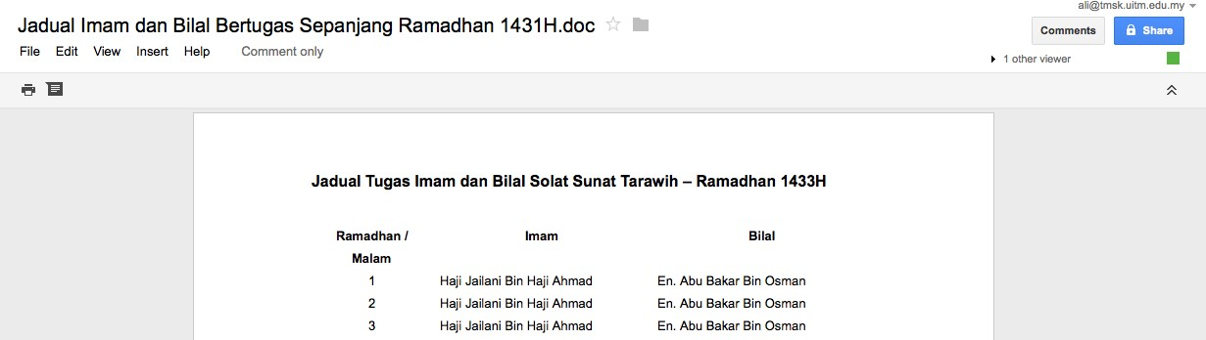

**Figure 23 Google Docs interface for commenter**

Notice that the menu bar does not have any control buttons. There are two buttons - print and add new comment. Note: it is advisable for the commenter to highlight the text or area in which the comment will be applicable.

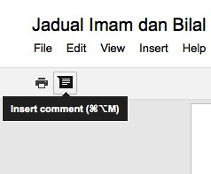

**Figure 24 Insert comment button**

When the Insert comment button is clicked, a comment panel will appear beside the document and allow the user to add a comment (Figure 23).

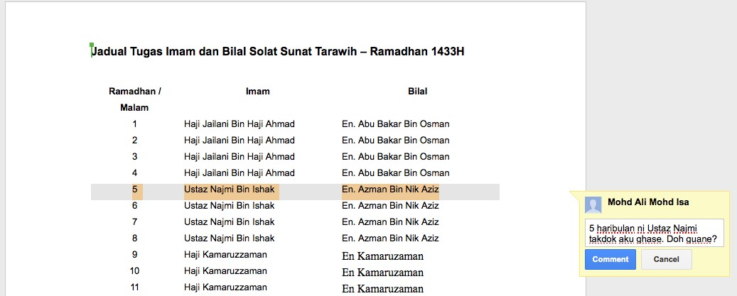

**Figure 25 Comment panel**

To comment, just type in message in the text field and click Comment. Since this is a real-time collaboration tool, if the owner of the file is online he/she will also able to see the comment.

